MINISTRY OF EDUCATION AND SCIENCE OF THE REPUBLIC

OF KAZAKHSTAN

INTERNATIONAL INFORMATION TECHNOLOGY UNIVERSITY

COMPUTER ENGINEERING AND INFORMATION

SECURITY DEPARTMENT

Python Project

Theme “Web-site”

Done by student Dokshina Anastasia

Imramziev Shahnazar

Group ITAC-1901R

Almaty 2020

Content

Introduction 3

Main part 3

First page 3

Second page 6

Third page 8

Questions: 10

Conclusion 10

References 10

# Introduction

In this project, we will be able to learn how to use the basic skills of python and django. We will also learn how to create a real working website that will be used on the Internet and go to another page using url.

# Main part

# First page

First we need to download python Django. To do this, use the following commands that are shown in the pictures.

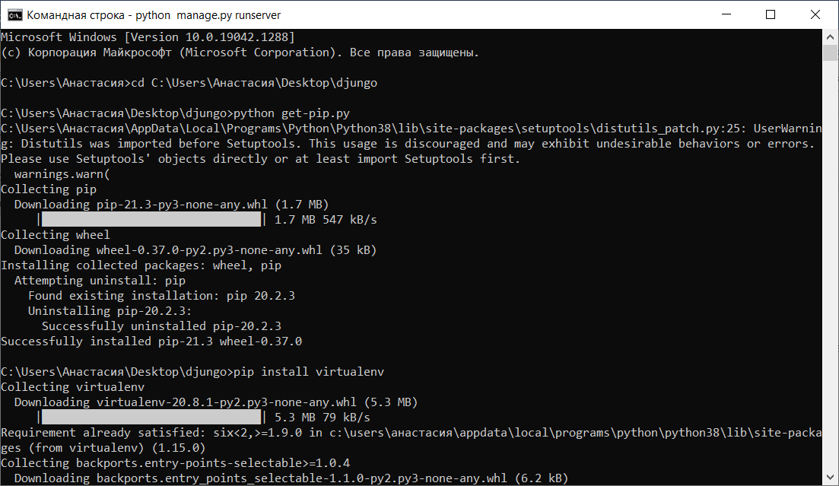

Then we create our project and write the path to it on the command line and to start the server we use (python manage.py runserver) and follow the link where we find our project.

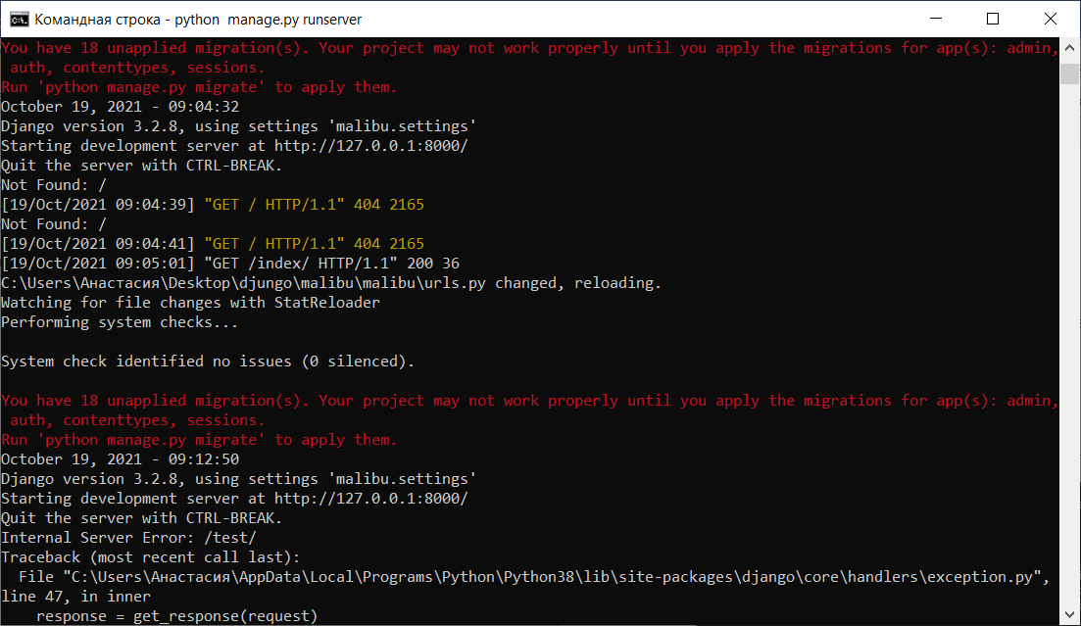

Since we need files to create sites, but we do not have them, we need to create them and below we see 3 created files in which we will write the code.

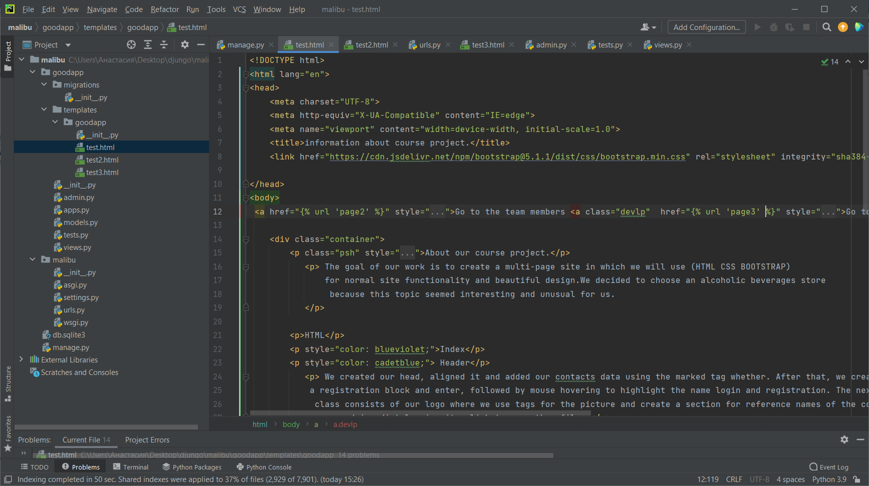

Since we need files to create sites, but we do not have them, we need to create them and below we see 3 created files in which we will write the code.

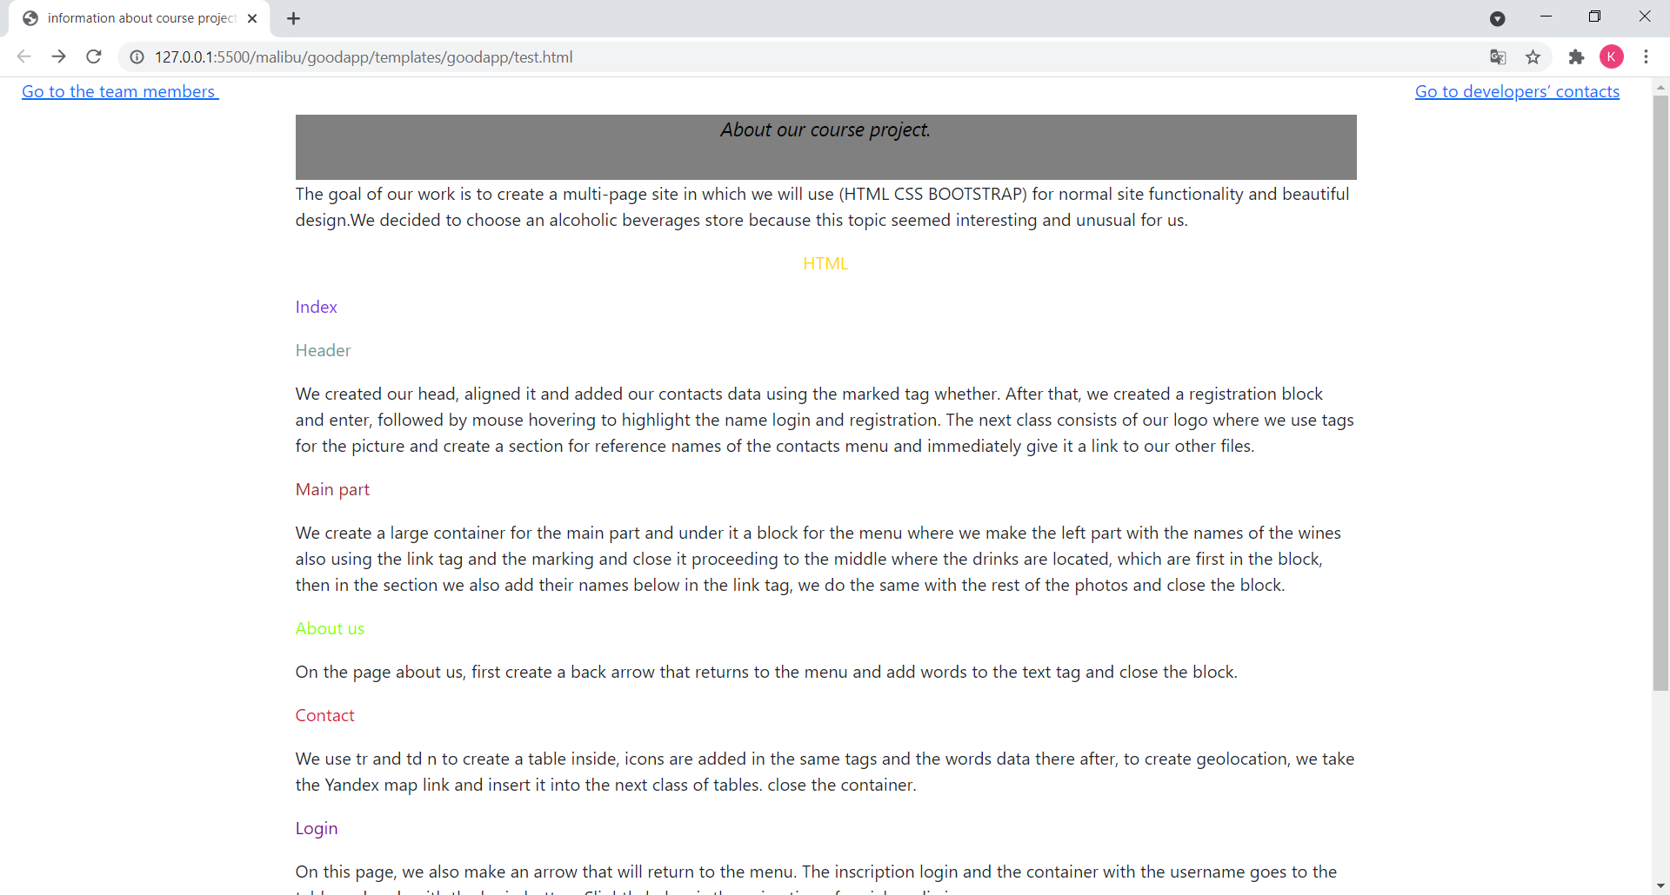

# Second page

Then you see the second page of the website, which shows the participants of this project, I also inserted pictures and information for presentation.

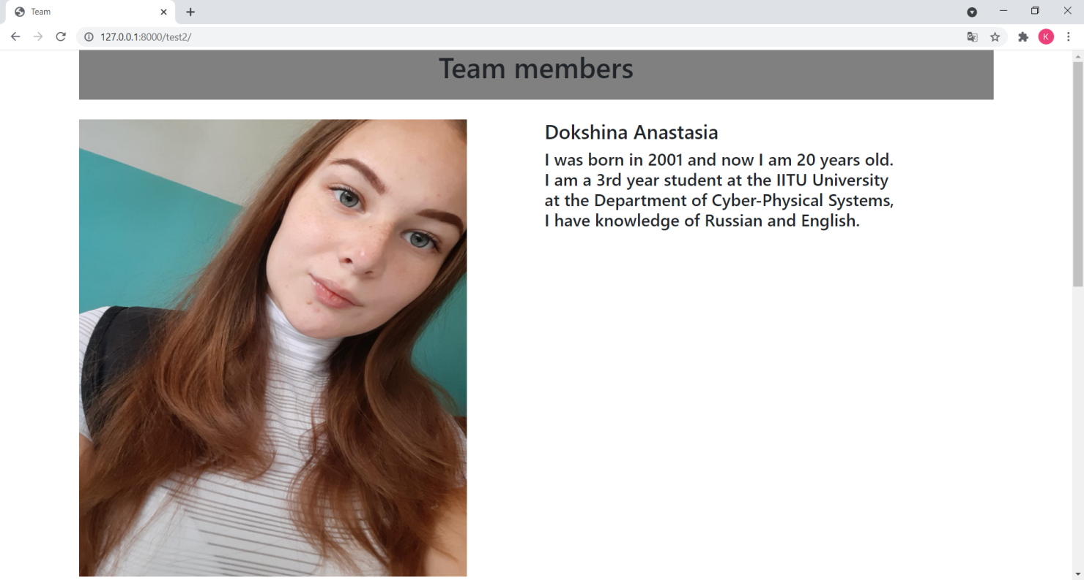

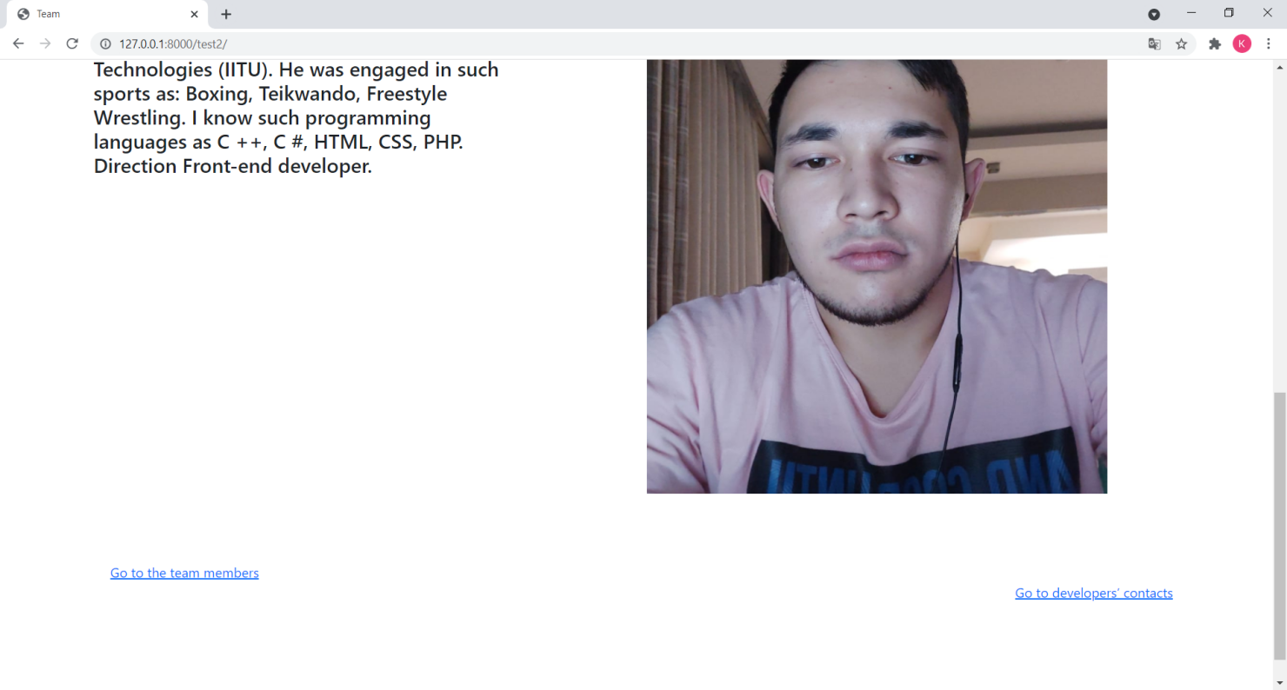

Views.py

In this picture, you can see the implementation of the function due to which the project is manifested.This is test our 1 page test2 our second page test3 for 3 page.All this function we used for representation it in the internet.

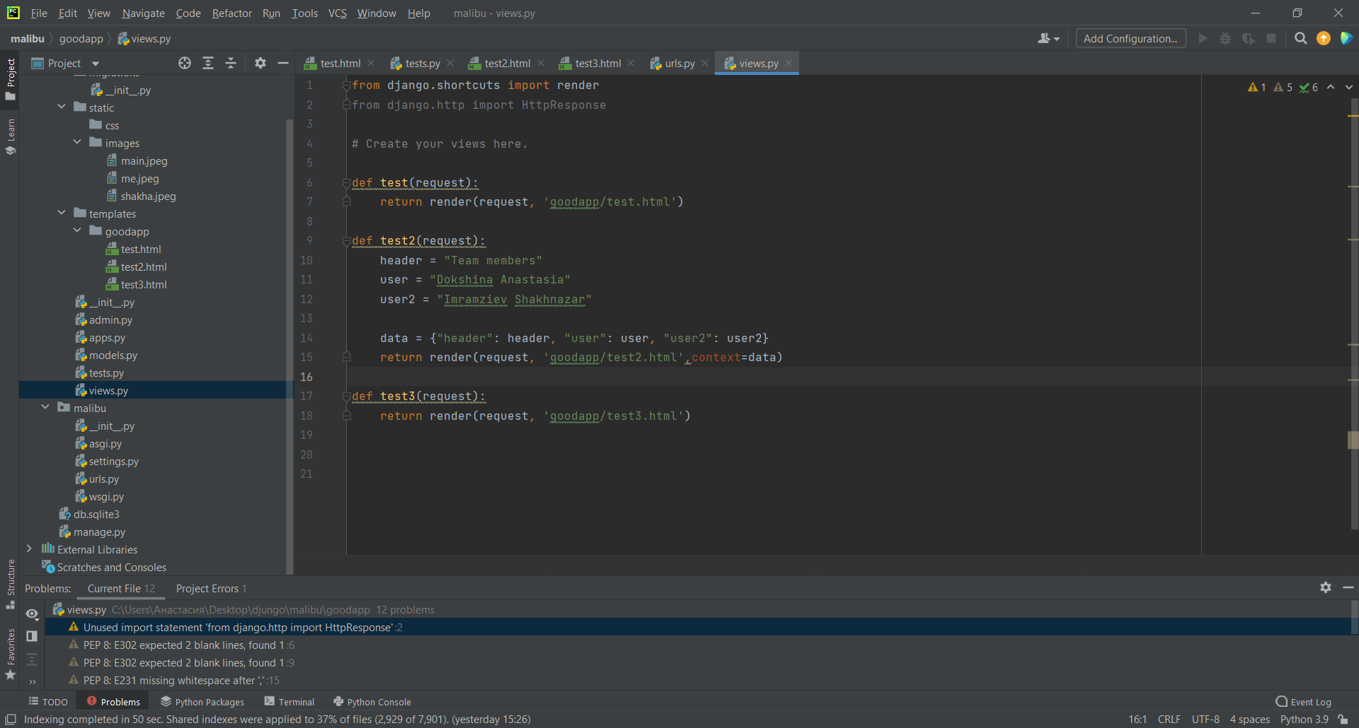

Url.py

We give a name to each page and its link to recognize it on the Internet so that you can correctly navigate to the page you need and the link you need.For this we create urls and path for not to loose path and name

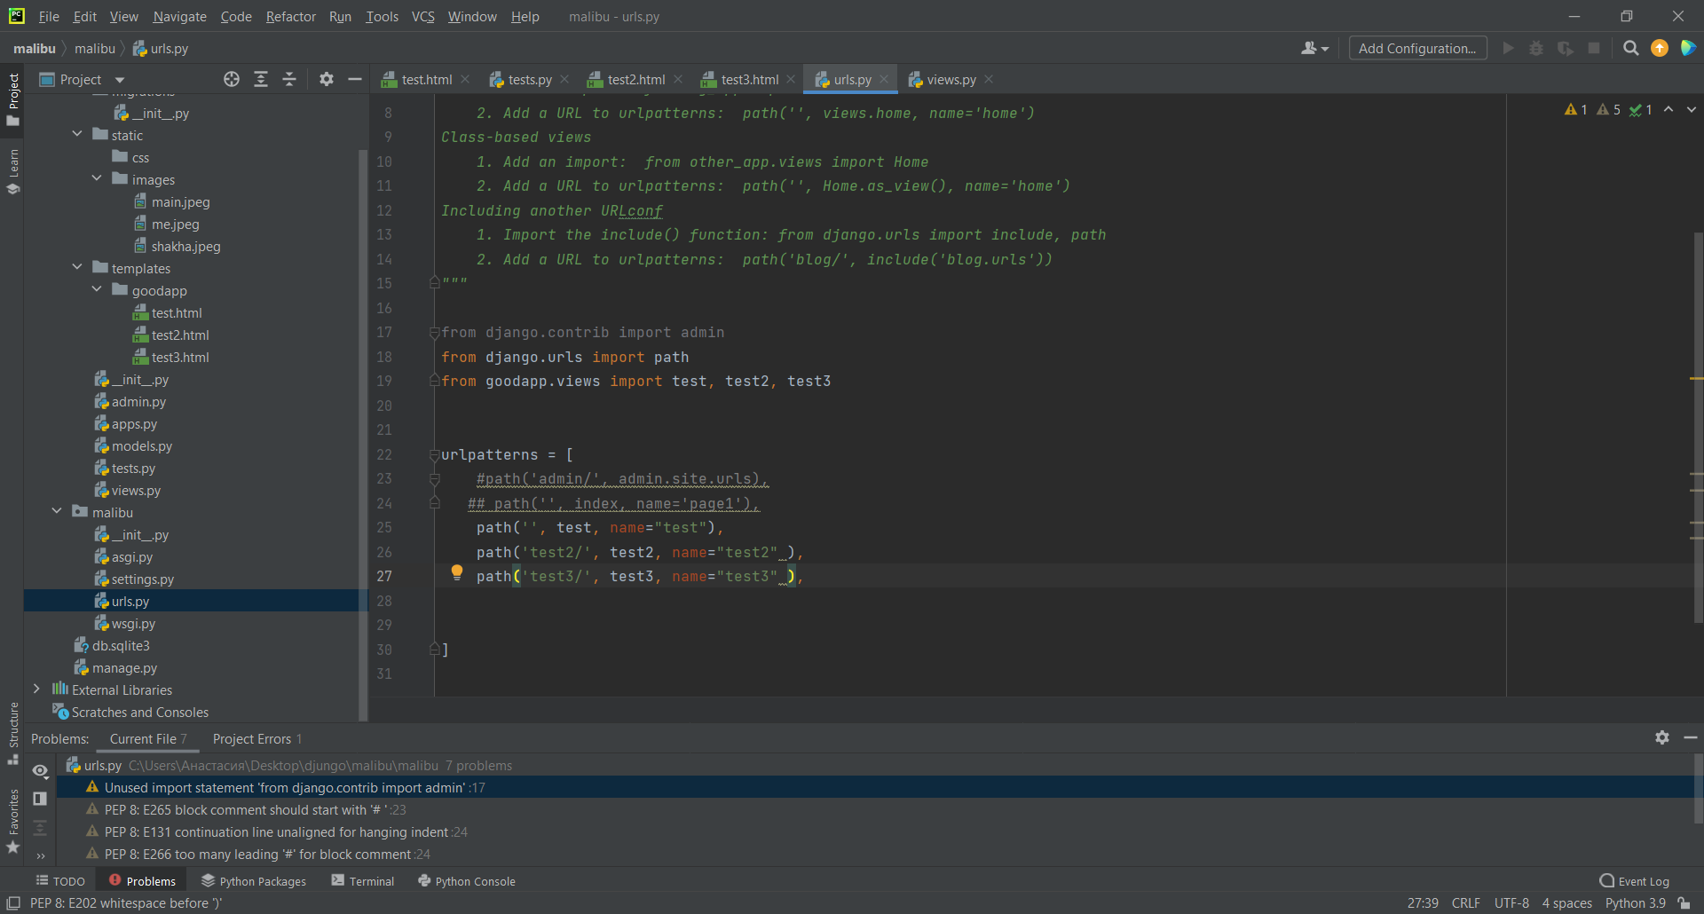

# Third page

We create variables that store contact data, which is our dictionary after we transfer them to our page for display.

Function render-combines a given template with a given context dictionary and returns an [HttpResponse](https://docs.djangoproject.com/en/3.2/ref/request-response/" \l "django.http.HttpResponse" \o "django.http.HttpResponse) object with that rendered text.Django does not provide a shortcut function which returns a [TemplateResponse](https://docs.djangoproject.com/en/3.2/ref/template-response/" \l "django.template.response.TemplateResponse" \o "django.template.response.TemplateResponse) because the constructor of [TemplateResponse](https://docs.djangoproject.com/en/3.2/ref/template-response/" \l "django.template.response.TemplateResponse" \o "django.template.response.TemplateResponse) offers the same level of convenience as [render()](https://docs.djangoproject.com/en/3.2/topics/http/shortcuts/" \l "django.shortcuts.render" \o "django.shortcuts.render).

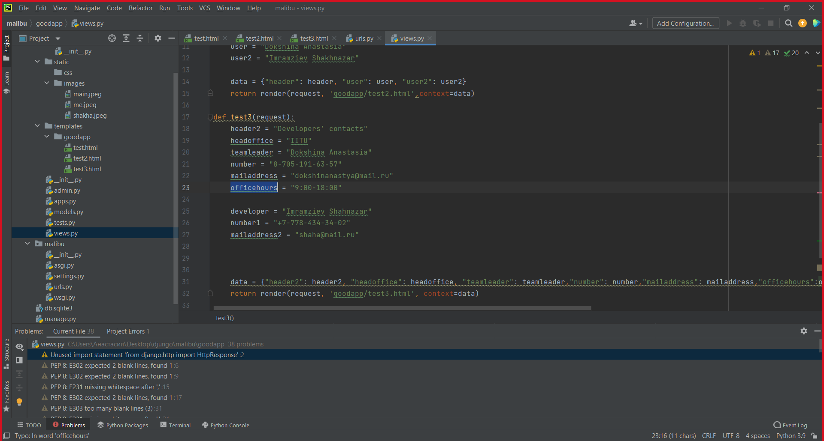

This page contains the contact details of the leader and developer, as well as the opening hours and our head office.

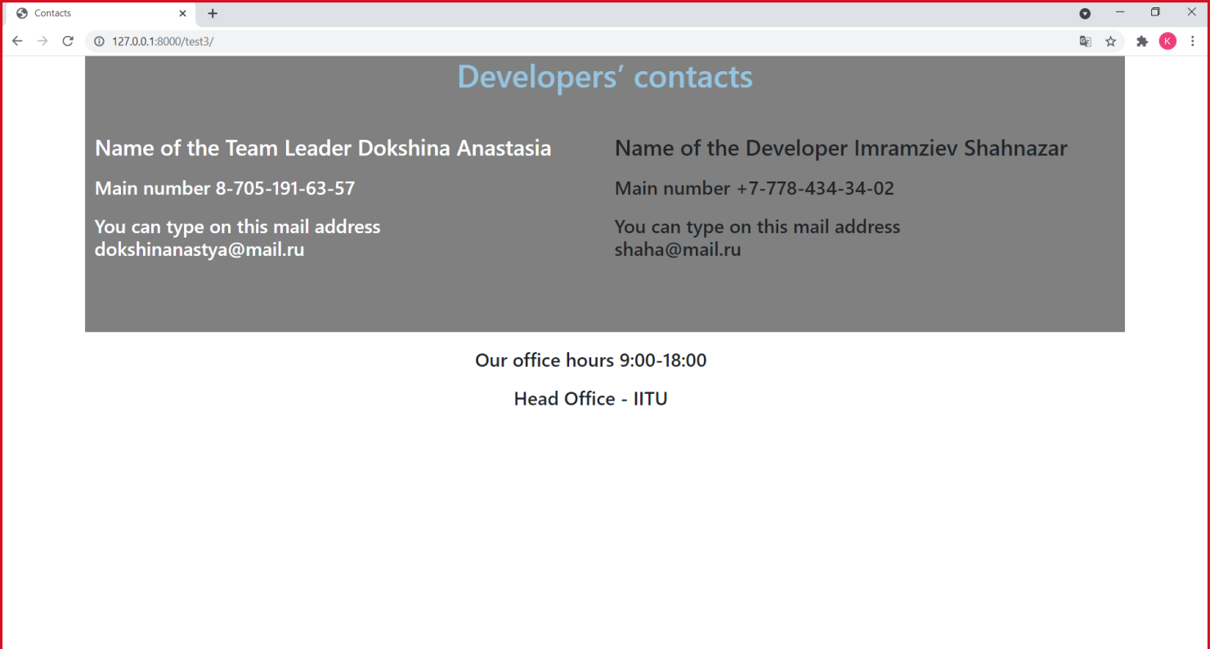

# Questions:

1. MVC pattern of the software development.

Many frameworks follow the MVC architectural pattern to separate the data model with business rules from the user interface. This is generally considered a good practice as it modularizes code, promotes code reuse, and allows multiple interfaces to be applied. In web applications, this permits different views to be presented, such as web pages for humans, and web service interfaces for remote applications.

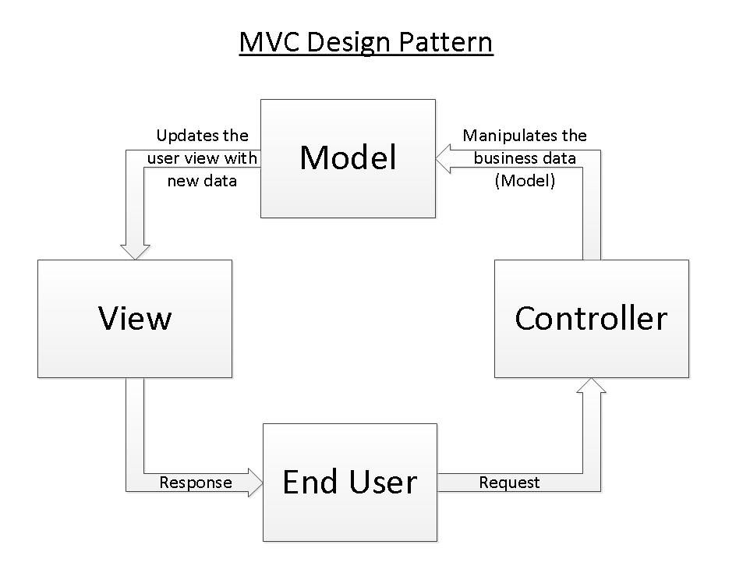

1. Overview on popular web frameworks.

1 Django is a py framework. Refers to high level. Allows you to create and maintain secure websites. It is characterized as free. Uses the MVC design pattern when working. The project is supported by the Django Software Foundation.

2 AngularJS is an open source JavaScript framework. Designed for developing single page applications. Its goal is to extend MVC-based browser applications and make testing and development easier.

The framework works with HTML, which contains additional custom attributes that are described by directives, and binds the input or output of a page region to a model, which is regular JavaScript variables. The values of these variables are set manually or retrieved from static or dynamic JSON data.

3 ASP.NET is a web application development platform that includes: web services, software infrastructure, programming model, from Microsoft.It contains many ready-made controls that can be used to quickly create interactive websites for those who have switched to ASP.NET from some other platform for developing web applications, or have never programmed in .NET applications for the web. The following sections will give you a quick overview of ASP.NET.

1. Choose two popular web frameworks and to carry out comparative analyzes.

**Django vs ASP.NET Core**

Developers describe **Django** as "The Web framework for perfectionists with deadlines". Django is a high-level Python Web framework that encourages rapid development and clean, pragmatic design. On the other hand, **ASP.NET Core** is detailed as "A cross-platform .NET framework for building modern cloud-based web applications on Windows, Mac, or Linux". A free and open-source web framework, and higher performance than ASP.NET, developed by Microsoft and the community. It is a modular framework that runs on both the full .NET Framework, on Windows, and the cross-platform .NET Core.

Also When assessing the two solutions, reviewers found ASP.NET easier to use and set up. However, Django is easier to administer. Reviewers also preferred doing business with Django overall.

* Reviewers felt that Django meets the needs of their business better than ASP.NET.
* When comparing quality of ongoing product support, reviewers felt that Django is the preferred option.
* When assessing product direction, ASP.NET and Django received similar ratings from our reviewers.

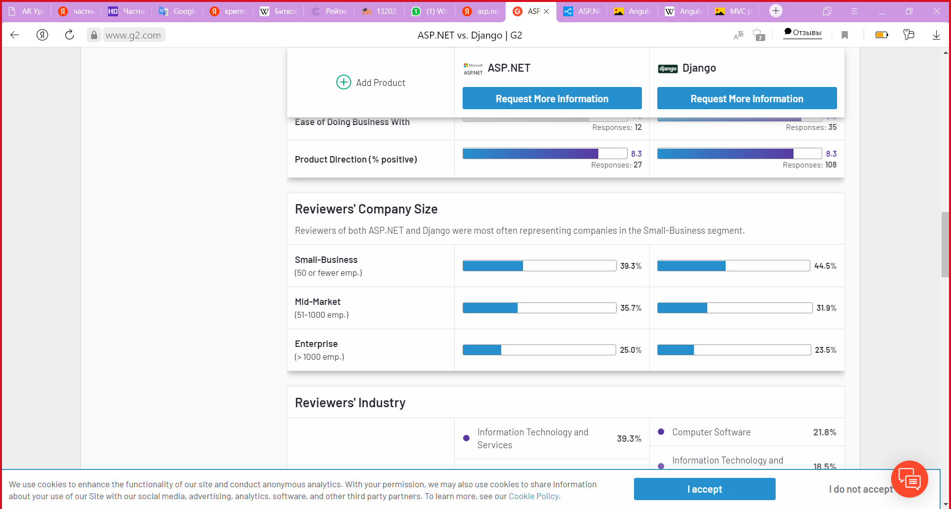

# Conclusion

# In this project, we have learned how to create a multi-page site that is created on the Internet and follows links to other pages as well as how to work with Python and HTML together.Also, creating functions and getting to know the Python program

# References

1 <https://djangodoc.ru/3.1/ref/templates/builtins/>

2 <https://rtfm.co.ua/django-book-osnovnye-tegi-i-filtry-shablona/>

3 <https://html5book.ru/html-tags/>

4 http://htmlbook.ru/html